All the rules in BSL language can be seen here: <https://courses.edx.org/courses/course-v1:UBCx+HtC1x+2T2017/a24b7341216346f2a5c99c6391f64229/>

Forming a function definition:

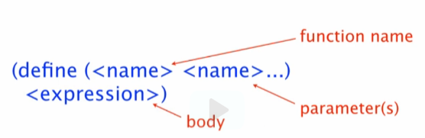

Forming a function call expression:

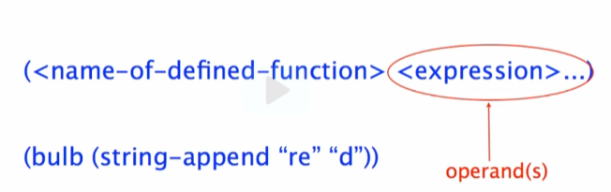

* Or: ([function-name] [arguments])

To evaluate primitive call

* Reduce operands to values (operands = args)
* Apply primitive operations to values

Function definition

* Record the definition

To evaluate function call



* Reduce operands to values (operands = args)



* Replace function call by
  + Body (expression) of the function in which every occurrence of the parameter(s) are replaced by the args

 ->  ->

 -> 